**Snapshot**

**Admin Side Screens:**

Screen 1: Admin login: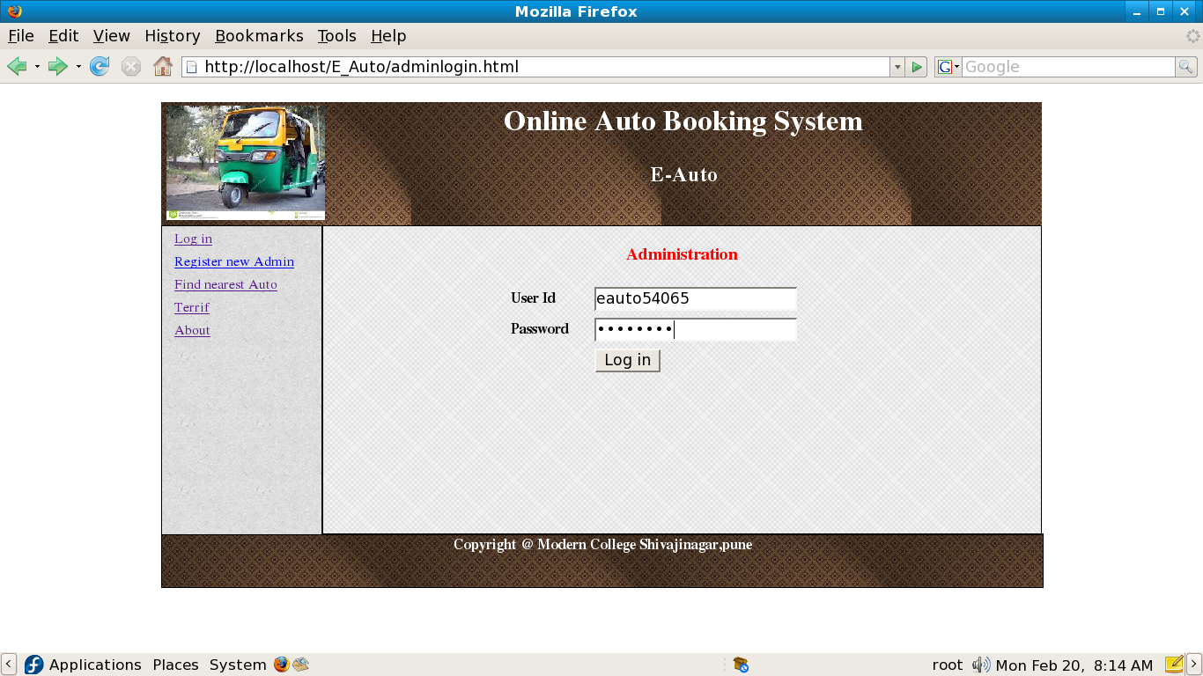

Screen 2: Admin Menu: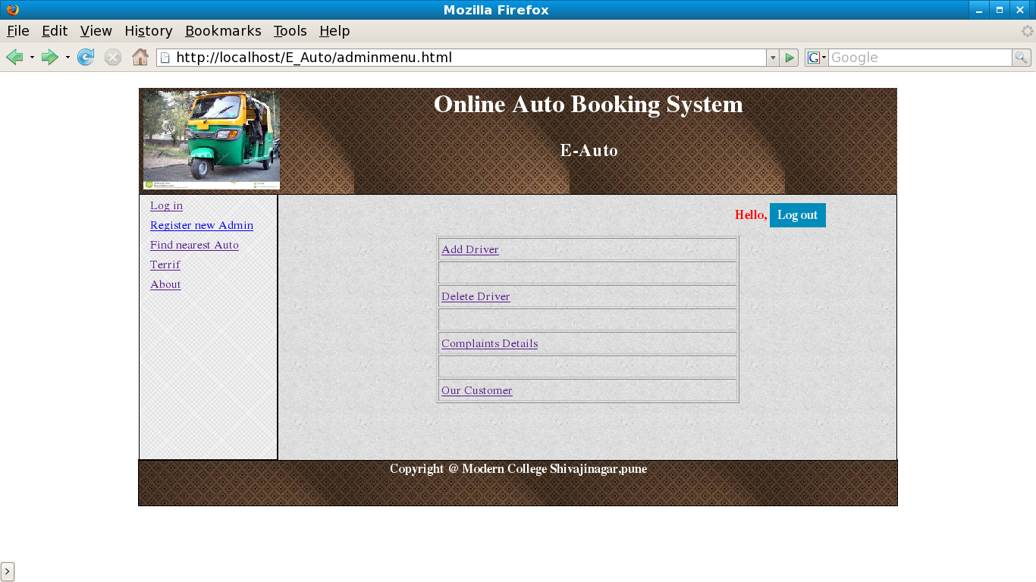

Screen 3: Admin Add Driver

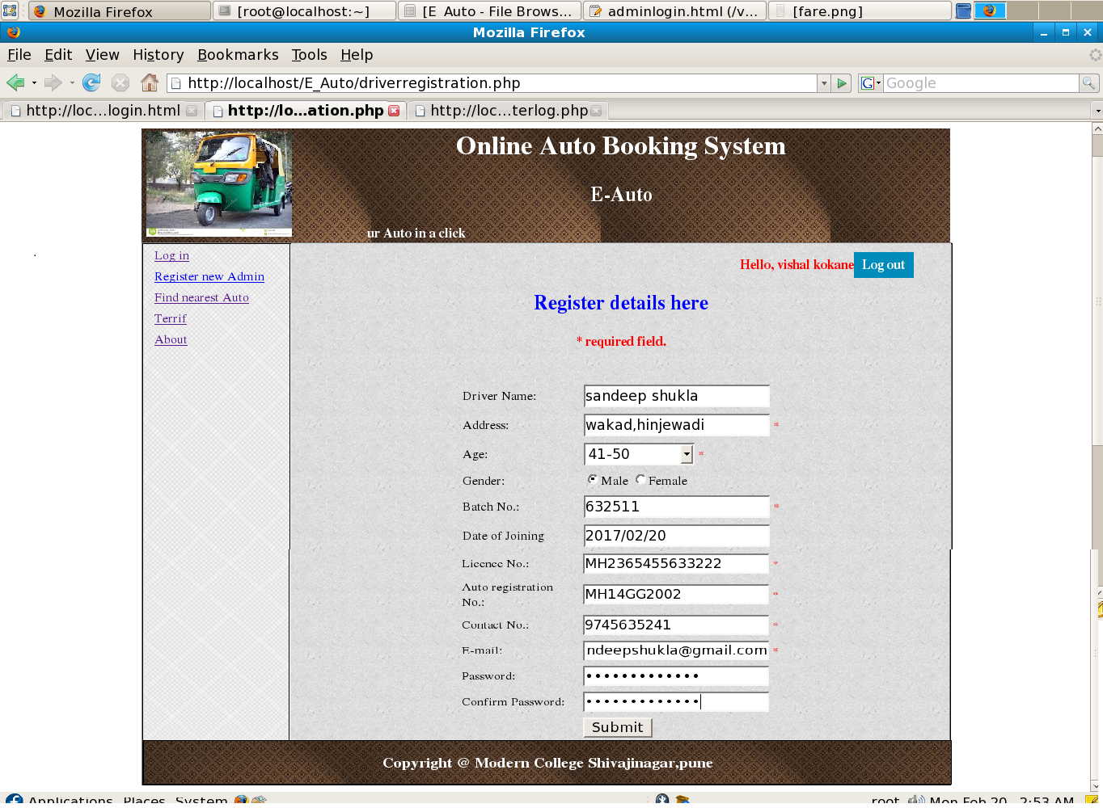

Screen 4: Admin Delete Driver

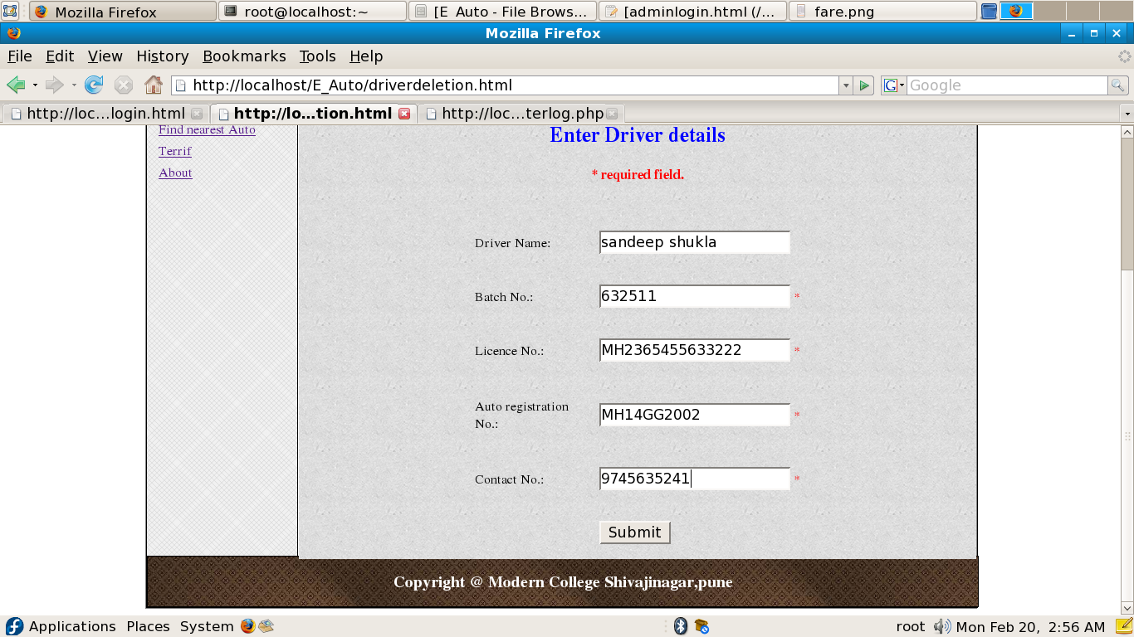

Screen 5: Handling Customer’s Complaints

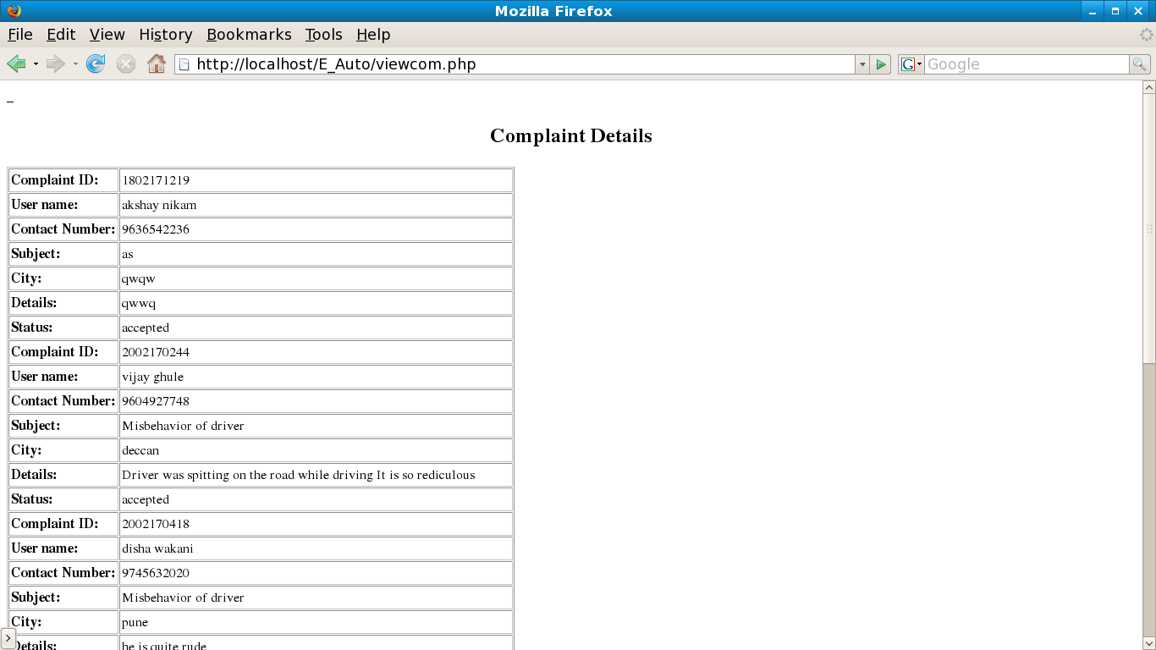

Screen 6: Viewing Customer Details

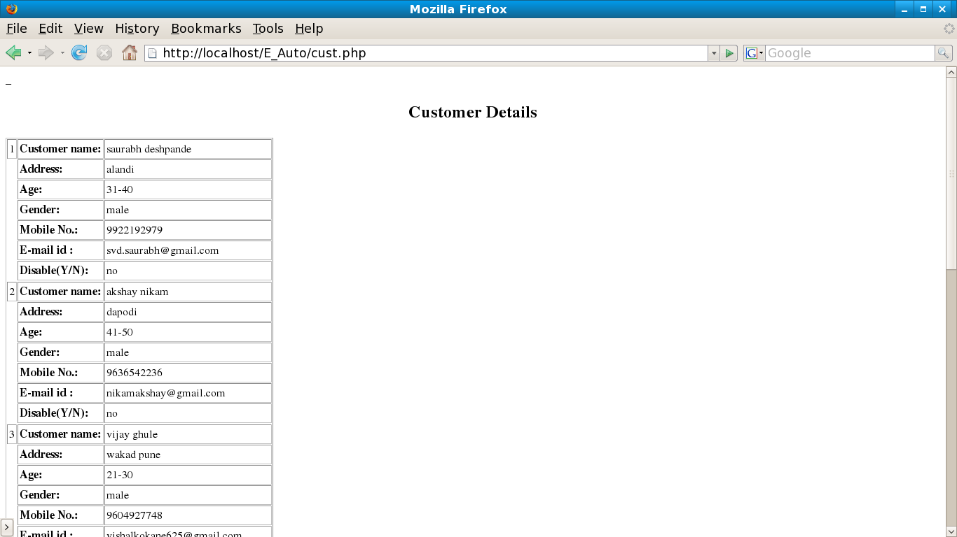

**Driver Side Screen**

Screen 1: Driver login

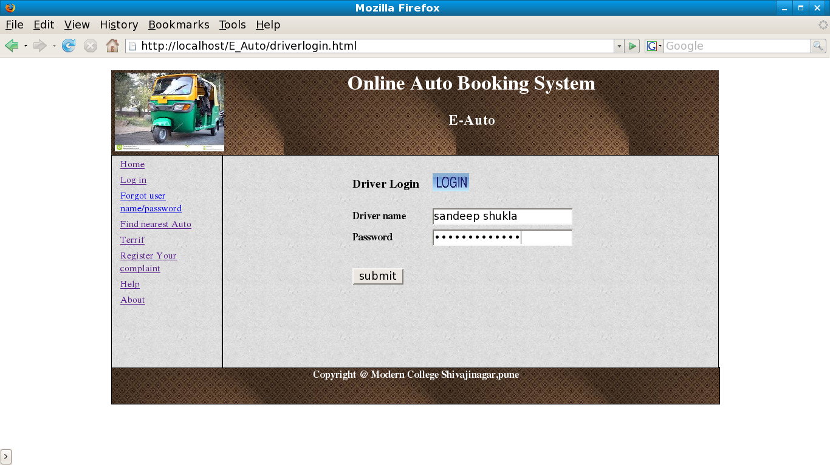

Screen 2: Unsuccessful driver login

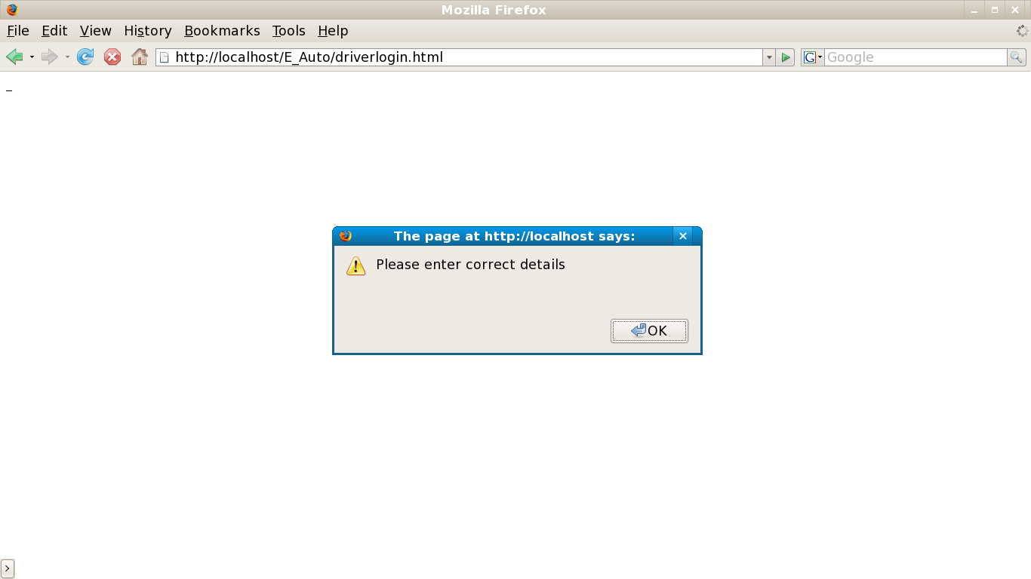

Screen 3: Driver Menu 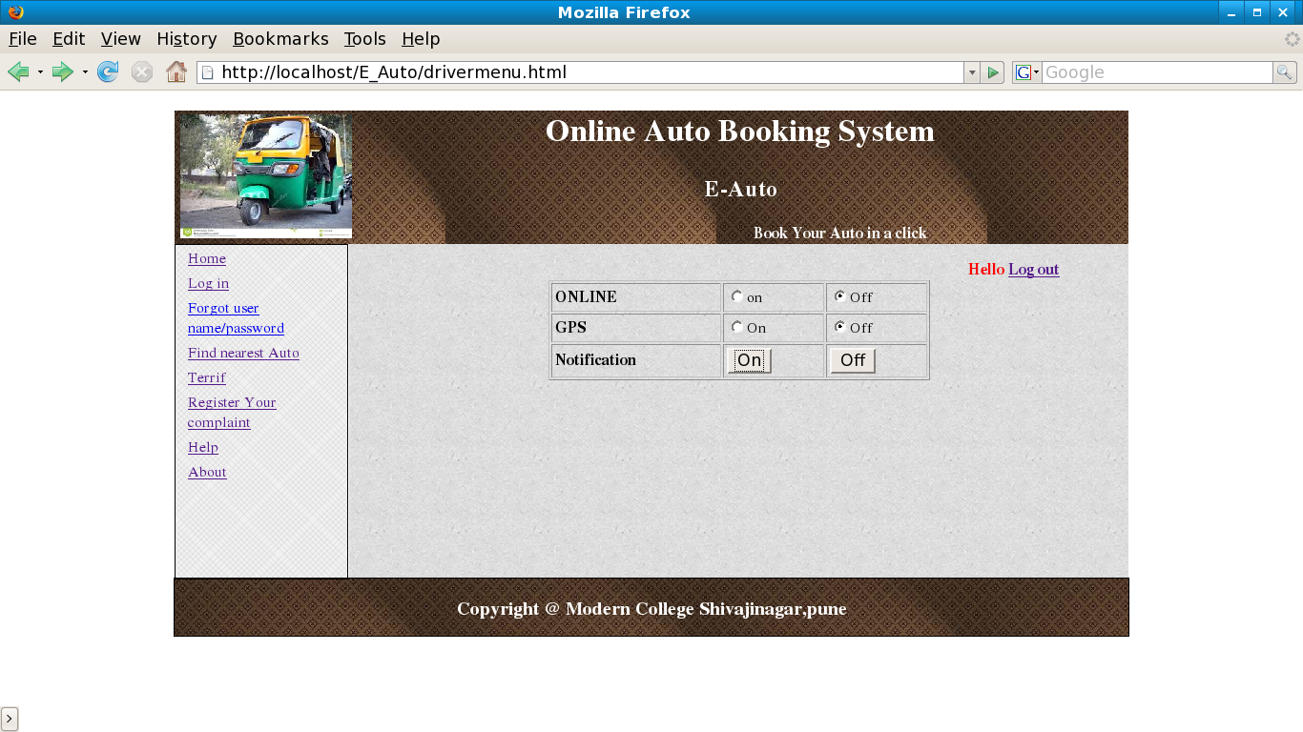

Screen 4: Notification to Driver

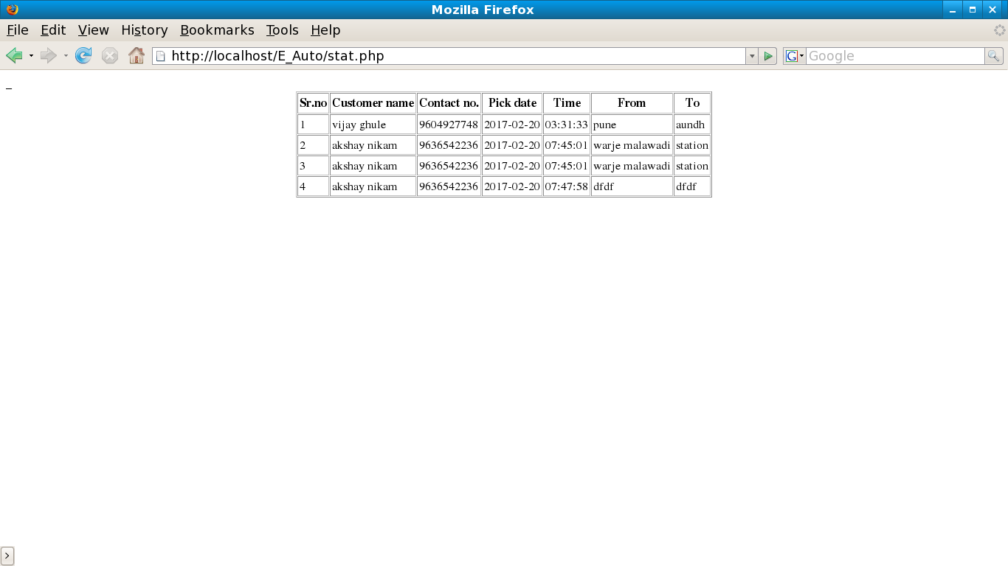

**Customer Side Screens**

Screen 1: Customer Registration

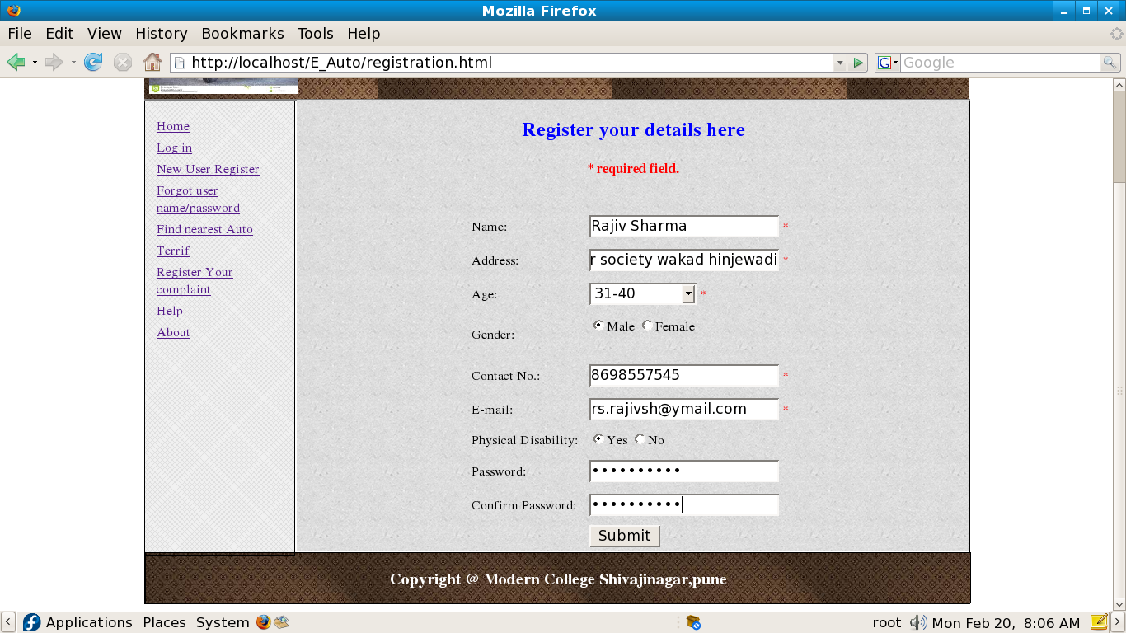

Screen 2: Successful Registration

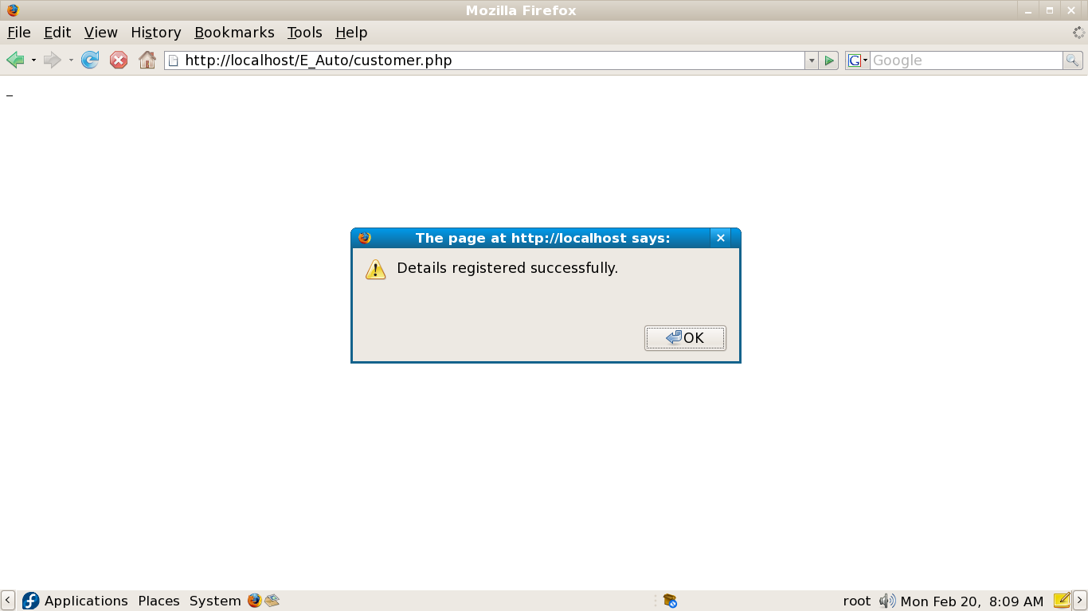

Screen 3: Customer login

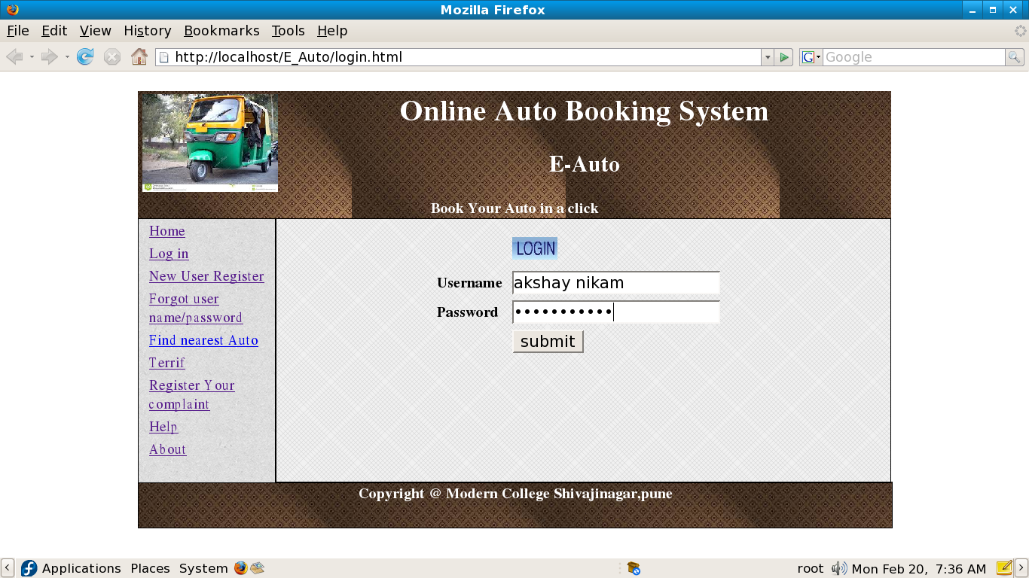

Screen 4: Driver Menu

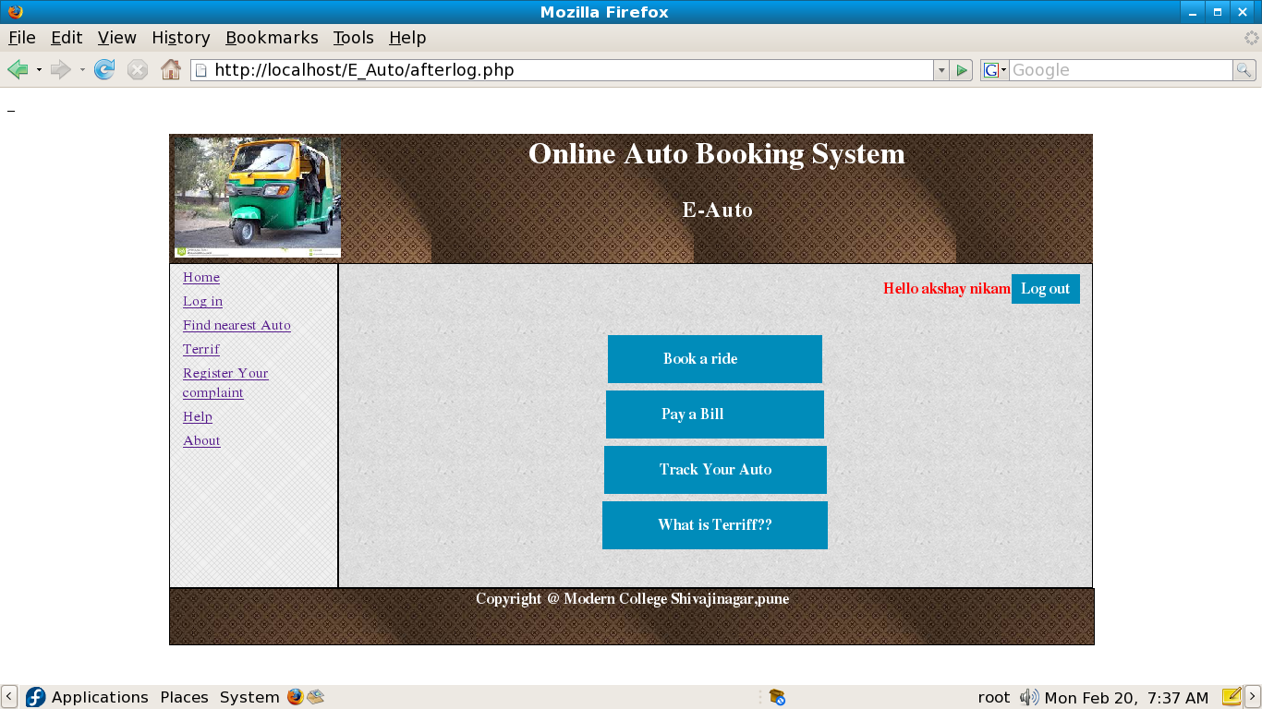

Screen 5: Booking of Auto

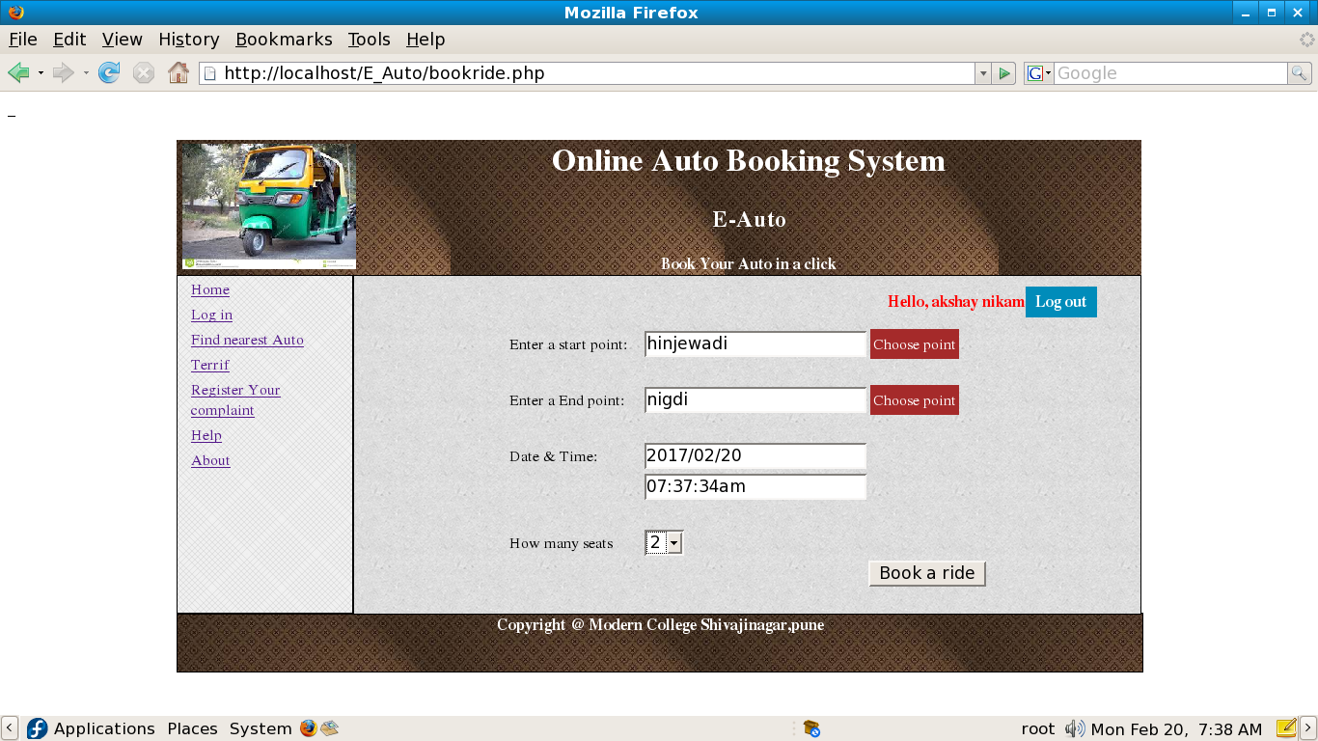

Screen 6: Successful Booking

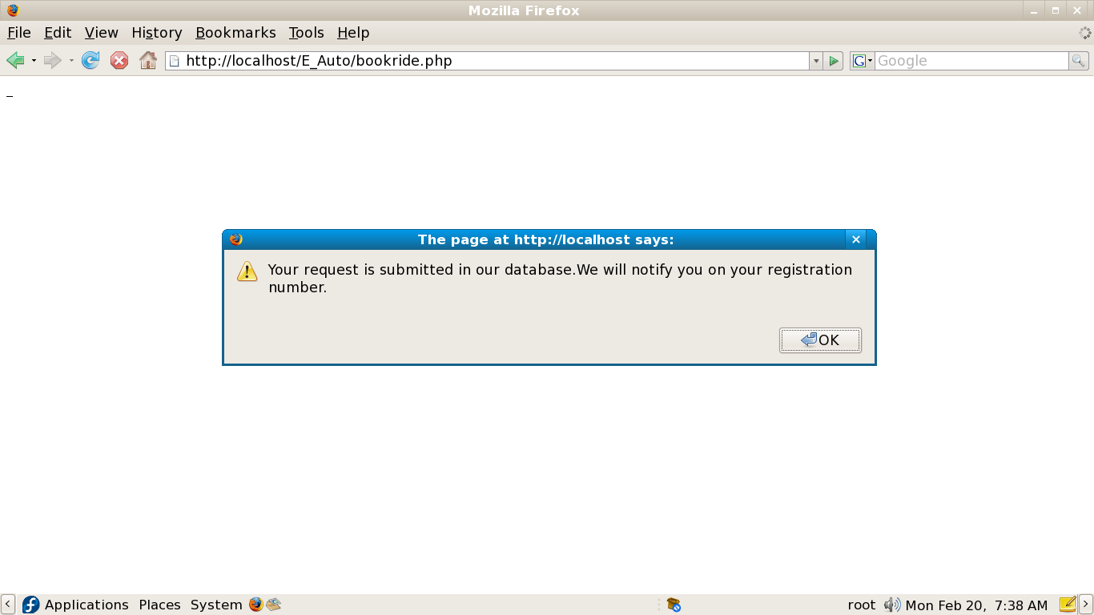

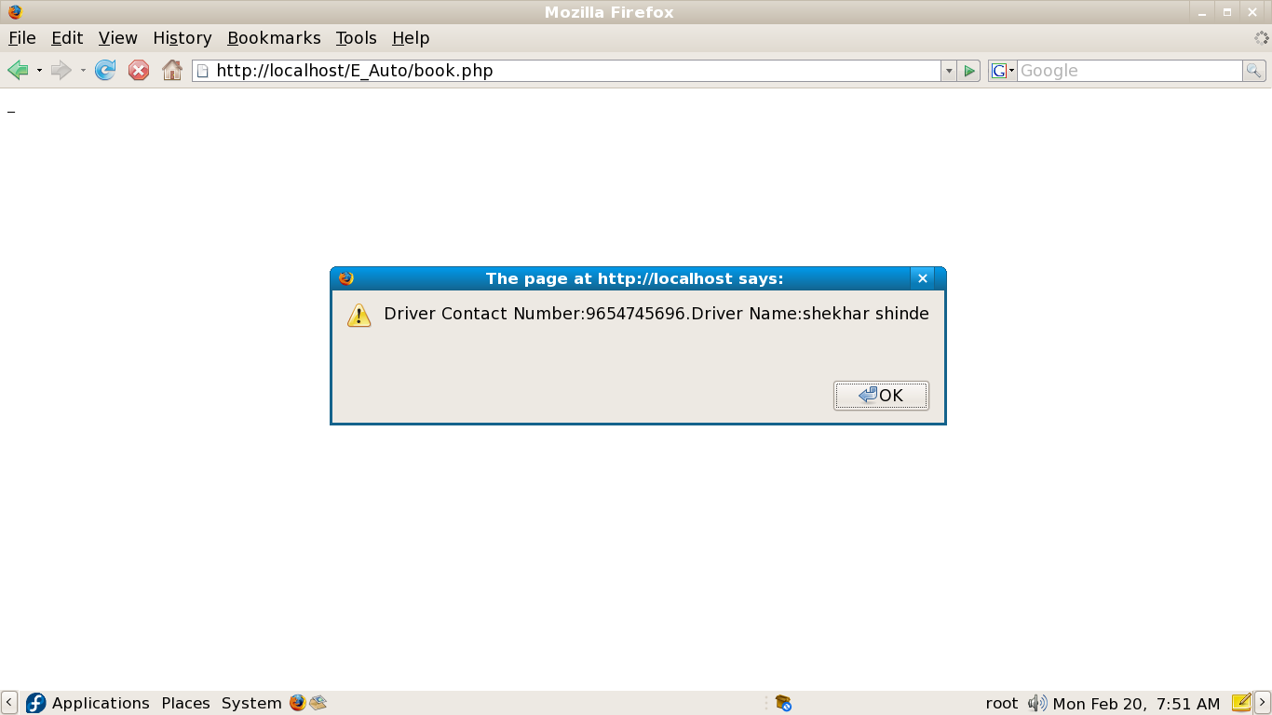

Screen 7: Bill payment



Screen 8: Credit Card /Debit Card Payment

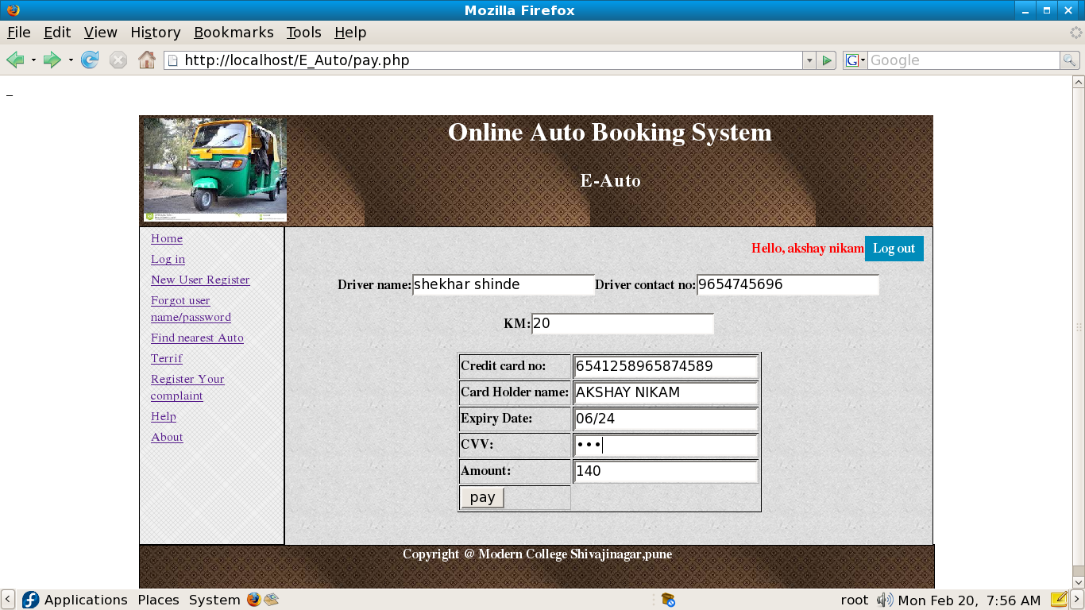

Screen 9: Paytm Payment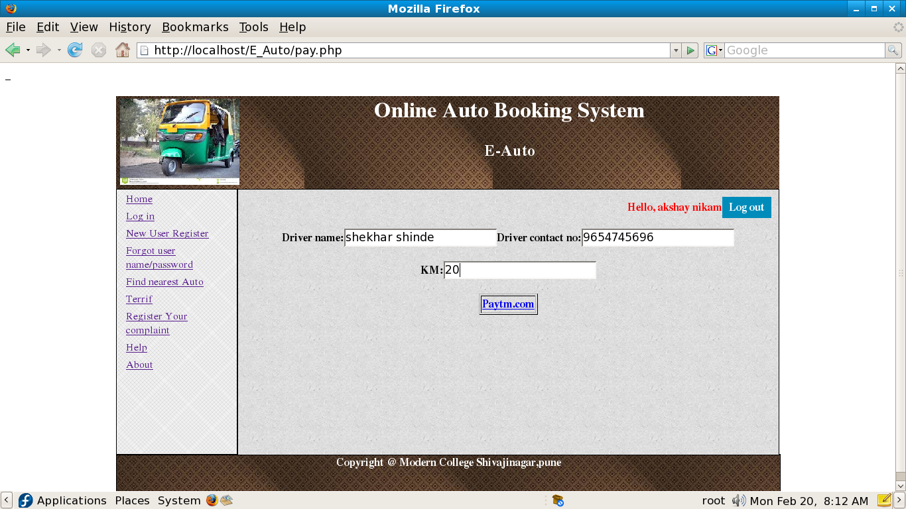

Screen 10: Successful Transcation

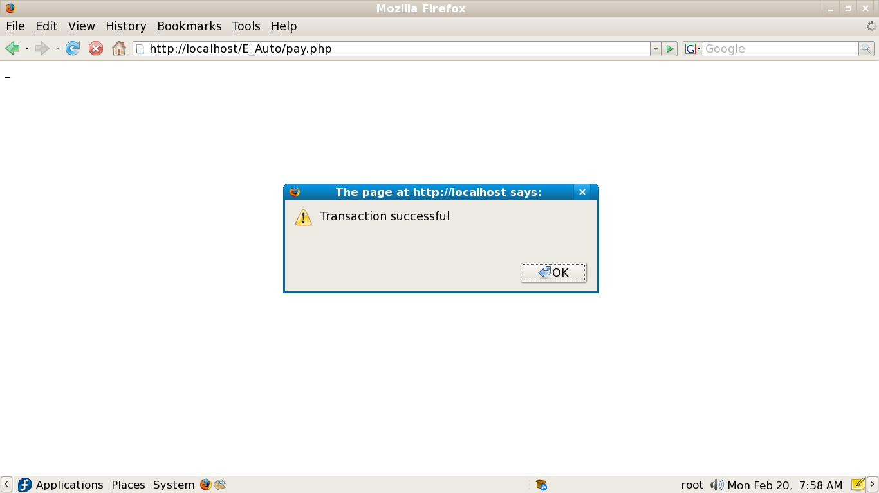

Screen 11: Teriff Card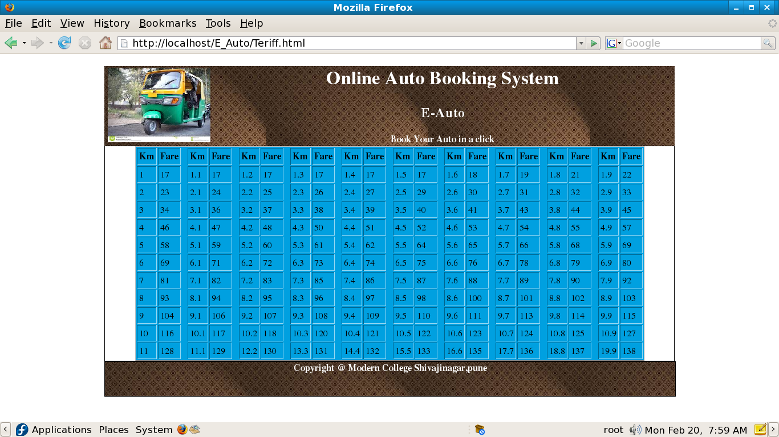

Screen 12: Finding nearest Auto

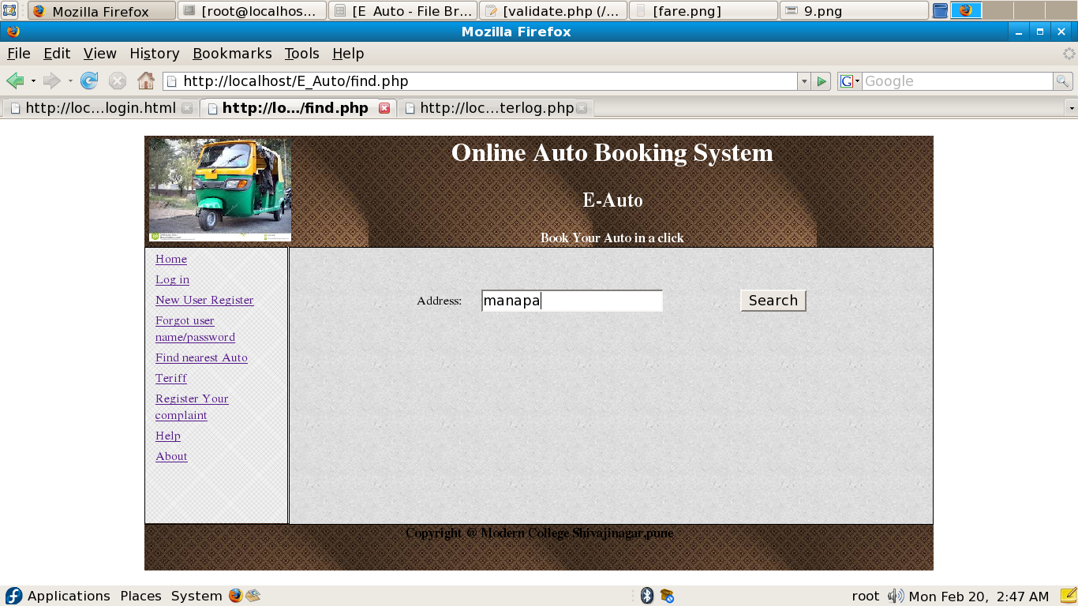

Screen 13: Registering Complaint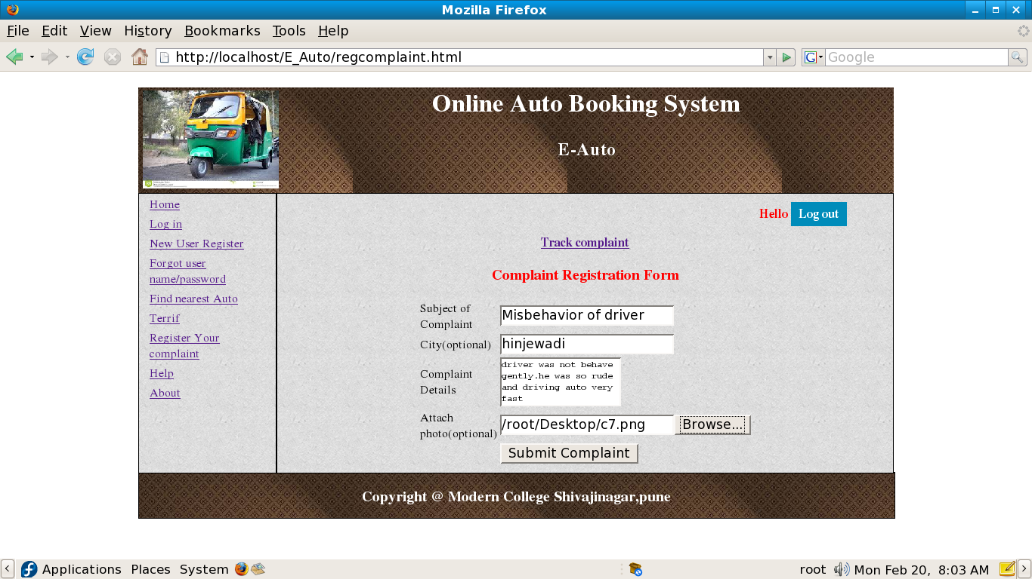

Screen 14: Successful Complaint Registration

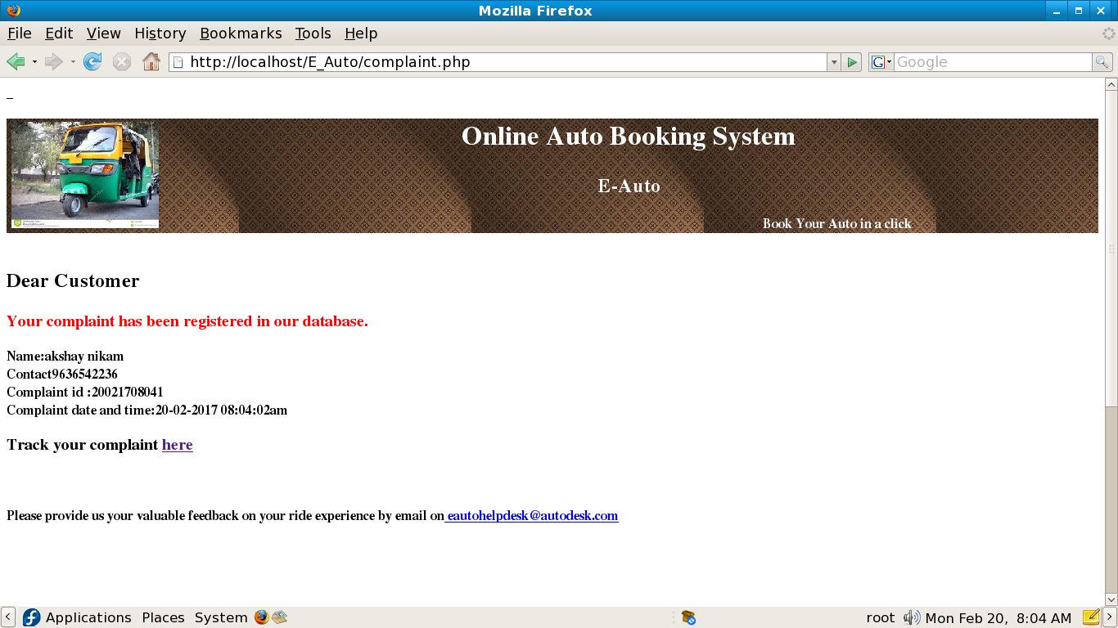

Screen 15: Track My Complaint

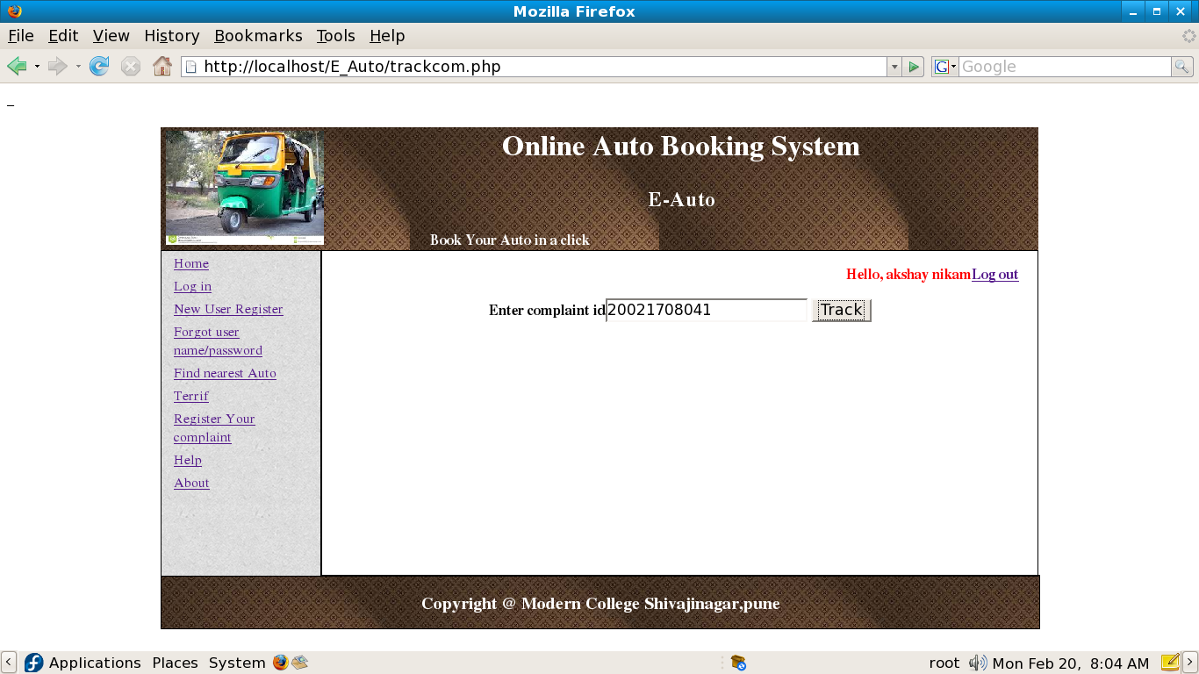

Screen 16: About E-Auto

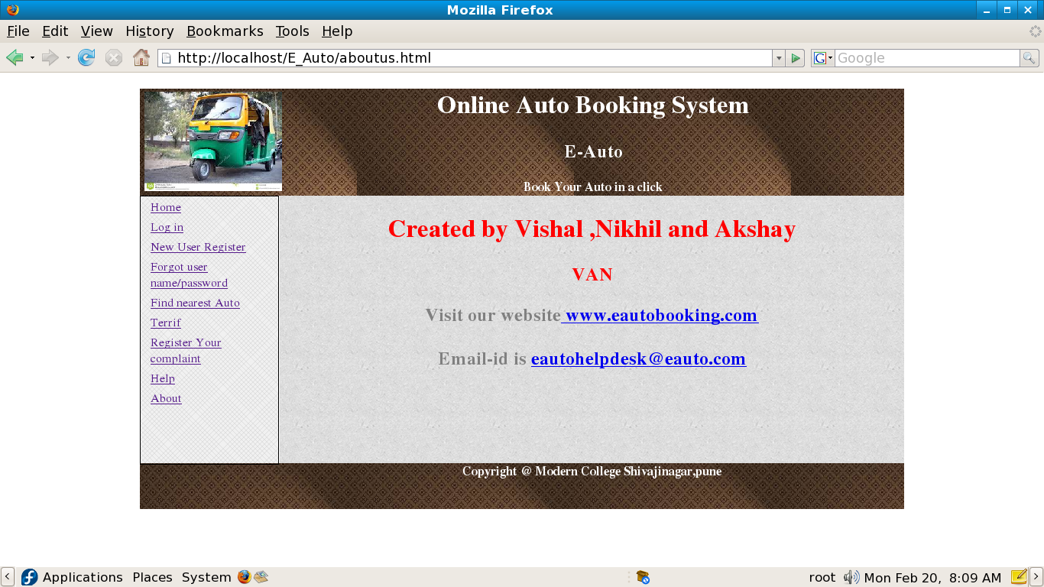

BIBILOGRAPHY

1. [www.google.com](http://www.google.com)
2. [www.w3schools.com](http://www.w3schools.com)